INFS 778 Deep Learning Quiz 1: Intro to Deep Neural Networks (total 25 points)
Due: 6/2 Sunday by Midnight 11:59 PM
- What is the size of a linear classifier (e.g. logistic regression classifier) weight matrix for CIFAR-10 images? (2 points)
Hint: The CIFAR-10 dataset consists of 60000 32x32 color images in 10 classes, with 6000 images per class. There are 50000 training images and 10000 test images. And input image pixels would be flattened.

1.Solution:
The CIFAR-10 dataset consists of 32x32 color images, meaning each image has 3 color channels (Red, Green, Blue). When these images are flattened into a vector for processing in a logistic regression classifier, each image is represented as a single 3072-dimensional vector (32 * 32 * 3 = 3072).

For logistic regression, where we classify into one of 10 classes, the weight matrix
𝑊
W must have a row for each feature (pixel value) and a column for each class:

Number of rows: equal to the number of features per image = 3072.
Number of columns: equal to the number of classes = 10.
Therfore, the size of the weight matrix W is 3072 x 10.

- Now, consider a simple nnet model for the above image classification problem. (5 points)
There is 1 hidden layer with 128 neurons.
What are the numbers of parameters (Weights and Biases) in each layer (input-hidden-output)? What is the total number of the parameters in the model?
While we are going to use ReLU activation for the hidden layer, what do you suggest for the output layer?

2.Solution:
Input to Hidden Layer: Each of the 3072 input features connects to 128 neurons in the hidden layer.

Weights: 3072 × 128
Biases: 128 (one for each neuron)
Hidden to Output Layer: Each of the 128 hidden layer neurons connects to each of the 10 output classes.

Weights: 128×10
Biases: 10 (one for each output class)
Total Parameters: 3072×128+128×10=393344
Biases: 128+10=138
Total: 393344 (weights) + 138 (biases) = 393482 parameters

Activation Functions:
Hidden Layer: ReLU (Rectified Linear Unit) is used because it helps with non-linear transformations and mitigates the vanishing gradient problem.
Output Layer: Softmax is suggested for the output layer since it's a multi-class classification problem. Softmax will output a probability distribution over the 10 classes.

- Now, consider a simple deep neural network model for the same problem. (6 points)
There are 4 hidden layers of ReLU activations: 128 – 128 – 32 – 32 neurons.
What are the numbers of parameters (Weights and Biases) in each layer (input-hidden-output)? What is the total number of the parameters in the model?

3.Solution:
Layers are connected as follows: Input (3072) → 128 → 128 → 32 → 32 → Output (10).
Weights and Biases for Each Layer:
Input to 1st Hidden: 3072×128, 128 biases
1st to 2nd Hidden: 128×128, 128 biases
2nd to 3rd Hidden: 128×32, 32 biases
3rd to 4th Hidden: 32×32, 32 biases
4th to Output: 32×10, 10 biases

Total Parameters:
Total weights: 393216+16384+4096+1024+320=415040
Total biases: 128+128+32+32+10=330
Overall: 415040+330=415370

- Now, consider the same model as the one in question 3 above and the size of the CIFAR-10 dataset. (3 points)
We are going to use 50000 images to train the model, for 10 epochs and with a mini-batch size of 256.
What is the total number of iterations during training?
Hint: Iterations is the number of batches needed to complete one epoch.

4.Solution:
Each epoch involves passing all training data through the network. The number of iterations per epoch is the total number of images divided by the batch size.
Iterations per Epoch: 50000/256≈195.31
Since we can't have a fraction of an iteration in practice, it rounds up to 196 iterations per epoch.
Total Iterations for 10 Epochs: 196×10=1960 iterations.

- We are going to use one hot encoding to process the CIFAR-10 dataset labels. (3 points)
What is the shape of the labels in the training set?
What does a label of “truck” in the training data look like after encoding?

Hint:
CIFAR10_LABELS_LIST = ['airplane', 'automobile', 'bird', 'cat', 'deer', 'dog', 'frog', 'horse', 'ship', 'truck']

5.Solution:

One Hot Encoding: Each class is represented as a binary vector which is as long as the number of
classes, with a '1' in the position of the class label and '0's elsewhere.

Shape: 50000 samples×10 classes
Encoding for "truck" (last class): [0,0,0,0,0,0,0,0,0,1]

- Consider the output layer with a softmax activation shown below. (6 points)
Note that we assume that the image only has 4 monochrome pixels, we are not considering color channels in this example for brevity, and that we have 3 classes.

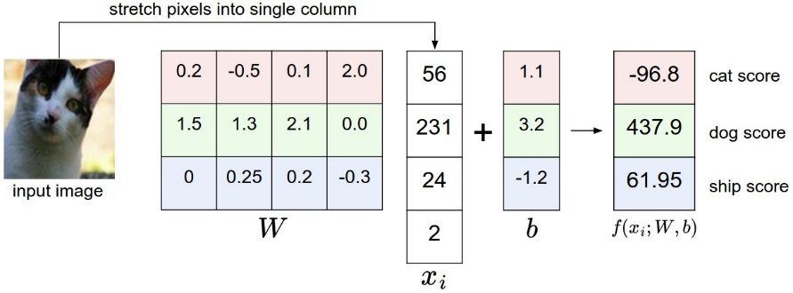
Calculate the outputs of the softmax activations. What is the prediction? Is the prediction good?
Hint: The softmax activation is given by
where z is given by

6.Solution:

Given That, Z= and its values are
-96.8 for cat score
437.9 dog score
61.95 ship score

Softmax Calculation
The softmax function is calculated as:
for each class j,

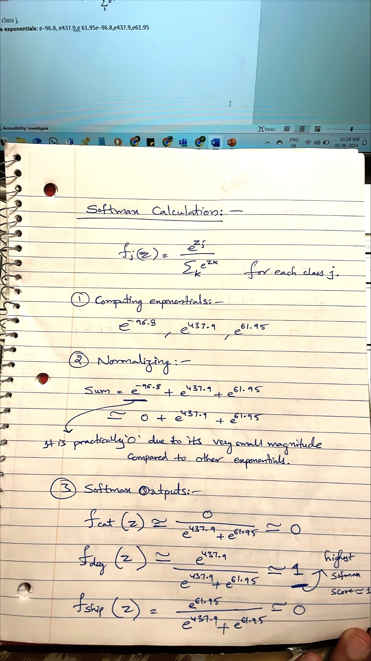
Prediction and Evaluation
The prediction is "dog" since it has the highest softmax score, close to 1. Given the dramatic difference in logits between the classes, where the dog score is significantly higher than the others, this is a strong and likely reliable prediction, indicating a good model performance for this specific input.

